RCB IPL Strategy — Task Sheet

Objective Questions
Q1 List the different dtypes of columns in table "ball_by_ball" (using information schema)
Output columns (in order): COLUMN_NAME, DATA_TYPE, IS_NULLABLE, COLUMN_KEY (4 columns)
Row count: 11 rows.

QUERY →
(Original query provided as a screenshot in the source document; image retained, but SQL was not extracted as text.)
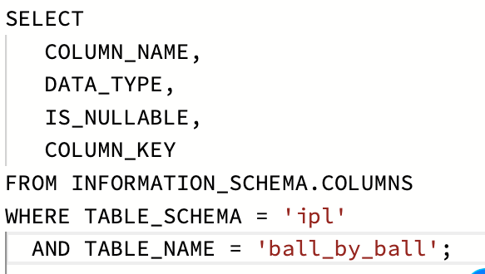

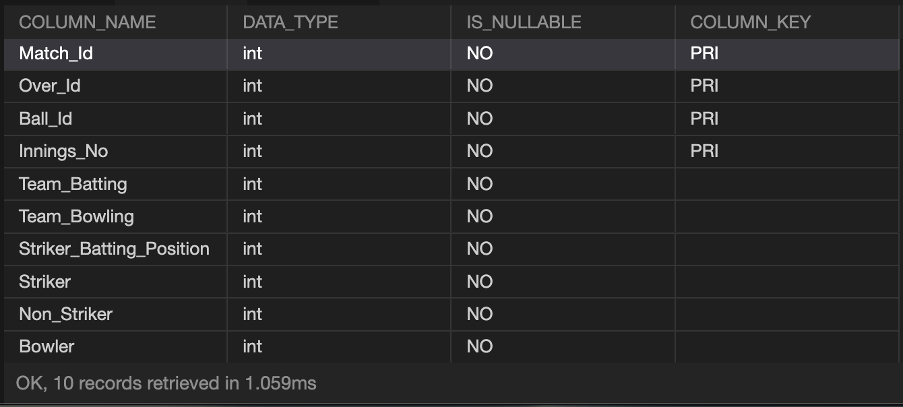

Q2 What is the total number of runs scored in 1st season by RCB (bonus: also include the extra runs using the extra runs table)
Output columns (in order): bat_runs, extra_runs, total_with_extras (3 columns)
Row count: 1 row (single aggregate row).

QUERY →
(Original query provided as a screenshot in the source document; image retained, but SQL was not extracted as text.)
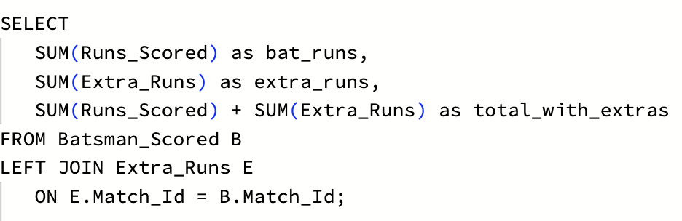

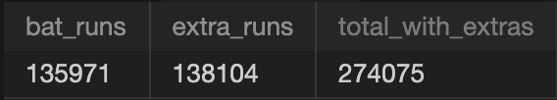

Q3 How many players were more than the age of 25 during season 2014?
Output columns (in order): players_over_25_in_2014 (1 column)

QUERY →
(Original query provided as a screenshot in the source document; image retained, but SQL was not extracted as text.)
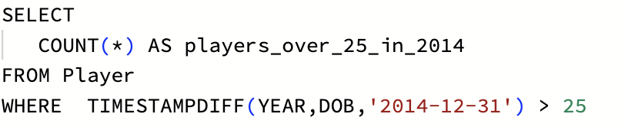



Row count: 1 row (single aggregate row).
Q4 How many matches did RCB win in 2013?
Output columns (in order): rcb_wins_2013 (1 column)
Row count: 1 row (single aggregate row).

QUERY →
SELECT
COUNT(*) AS rcb_wins_2013
FROM Matches m
JOIN Season s
ON s.Season_Id = m.Season_Id
JOIN Team t
ON t.Team_Id = m.Match_Winner
WHERE YEAR(m.Match_Date) = '2013'
AND t.Team_Name = 'Royal Challengers Bangalore';
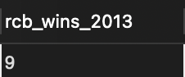

Q5 List the top 10 players according to their strike rate in the last 4 seasons
Output columns (in order): Player_Name, runs, balls_faced, strike_rate (4 columns)
Row count: 10 rows (LIMIT 10).

QUERY →
WITH last_four_seasons AS (
SELECT Season_Id
FROM Season
ORDER BY Season_Year DESC
LIMIT 4
)

SELECT
p.Player_Name,
SUM(bs.Runs_Scored) as runs,
COUNT(*) as balls_faced,
(SUM(bs.Runs_Scored) * 100)/COUNT(*) as strike_rate

FROM Batsman_Scored bs
JOIN Ball_by_Ball bbb
ON bbb.Match_Id = bs.Match_Id
AND bbb.Over_Id = bs.Over_Id
AND bbb.Ball_Id = bs.Ball_Id
AND bbb.Innings_No = bs.Innings_No
JOIN Player p
ON p.Player_Id = bbb.Striker
JOIN Matches m
On m.Match_Id = bbb.Match_Id
JOIN last_four_seasons ls
On ls.Season_Id = m.Season_Id
GROUP BY
p.Player_Id,
p.Player_Name
ORDER BY strike_rate DESC
LIMIT 10;

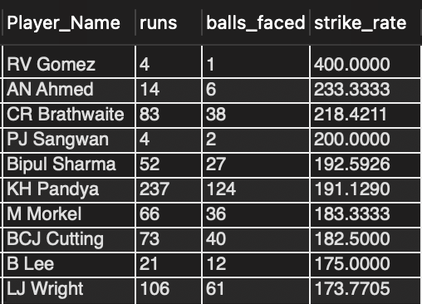

Q6 What are the average runs scored by each batsman considering all the seasons?
Output columns (in order): Player_Name, total_runs, matches, avg_runs_per_match (4 columns)
Row count: 259 rows (1 row per distinct batsman who faced at least 1 ball).
QUERY →
WITH avg_runs as(
SELECT
p.Player_Name,
SUM(bs.Runs_Scored) as total_runs,
COUNT(DISTINCT bbb.Match_Id) as Matches,
ROUND(SUM(bs.Runs_Scored) / COUNT(DISTINCT bbb.Match_Id), 2) AS avg_runs_per_match
FROM Batsman_Scored bs
JOIN Ball_by_Ball bbb
ON bbb.Match_Id = bs.Match_Id
AND bbb.Over_Id = bs.Over_Id
AND bbb.Ball_Id = bs.Ball_Id
AND bbb.Innings_No = bs.Innings_No
JOIN Player p
ON p.Player_Id = bbb.Striker
GROUP BY
p.Player_Id,
p.Player_Name
ORDER BY avg_runs_per_match DESC )
SELECT * FROM avg_runs;

Q7 What are the average wickets taken by each bowler considering all the seasons?
Output columns (in order): Player_Name, total_wickets, matches, avg_wickets_per_match (4 columns)
Row count: 174 rows (1 row per distinct bowler credited with ≥1 wicket).

QUERY →
SELECT
p.Player_Name,
COUNT(*) as total_wickets,
COUNT(DISTINCT bbb.Match_Id),
ROUND(COUNT(*) * 1.0 / COUNT(DISTINCT bbb.Match_Id), 2) as avg_wickets_per_match
FROM Wicket_Taken wt
JOIN Ball_by_Ball bbb
ON wt.Match_Id = bbb.Match_Id
AND wt.Over_Id = bbb.Over_Id
AND wt.Ball_Id = bbb.Ball_Id
AND wt.Innings_No = bbb.Innings_No
JOIN Player p
ON bbb.Bowler = p.Player_Id
WHERE wt.Kind_Out NOT IN (3,5,9)
GROUP BY
bbb.Bowler,
p.Player_Name

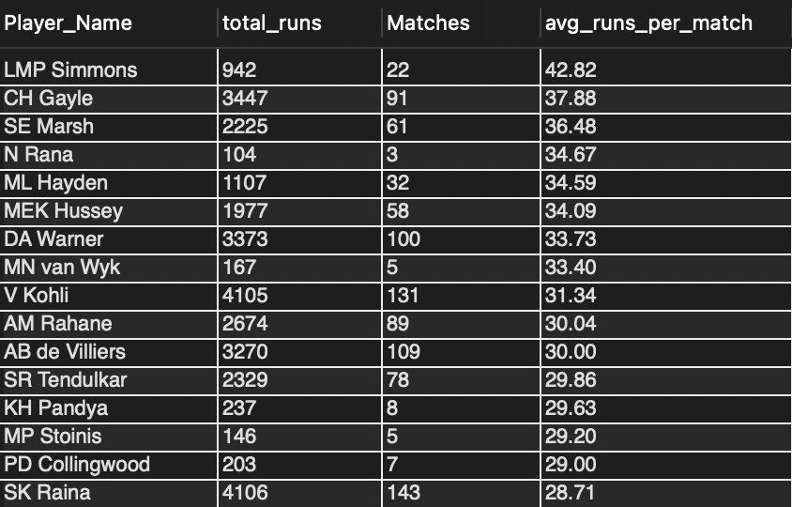

Q8 List all the players who have average runs scored greater than the overall average and who have taken wickets greater than the overall average
Output columns (in order): Player_Name, avg_runs, avg_wkts (3 columns)
Row count: Varies depending on interpretation.

QUERY →
WITH runs_total as (
SELECT
DISTINCT(bbb.Striker) as Player_Id,
SUM(bs.Runs_Scored) as total_runs
FROM Batsman_Scored bs
JOIN Ball_by_Ball bbb
ON bbb.Match_Id = bs.Match_Id
AND bbb.Over_Id = bs.Over_Id
AND bbb.Ball_Id = bs.Ball_Id
AND bbb.Innings_No = bs.Innings_No
JOIN Player p
On p.Player_Id = bbb.Striker
GROUP BY
bbb.Striker
),

wicket_totals as (
SELECT
bbb.Bowler as Bowler_Id,
COUNT(*) as total_wickets
FROM Wicket_Taken wt
JOIN Ball_by_Ball bbb
ON wt.Match_Id = bbb.Match_Id
AND wt.Over_Id = bbb.Over_Id
AND wt.Ball_Id = bbb.Ball_Id
AND wt.Innings_No = bbb.Innings_No
JOIN Out_Type ot
ON wt.Kind_Out = ot.Out_Id
WHERE LOWER(ot.Out_Name) IN ('caught','bowled', 'lbw', 'stumped', 'caught and bowled', 'hit wicket')
GROUP BY Bowler_Id
),

match_totals as (
SELECT
p.Player_id,
COUNT(DISTINCT Match_Id) as matches
FROM Player p
JOIN Player_Match pm
ON pm.Player_id = p.Player_id
GROUP BY p.Player_id
),

player_avgs as (
SELECT
mt.Player_Id,
(CASE
WHEN rt.total_runs IS NOT NULL
THEN ROUND((rt.total_runs /mt.matches), 2)
END ) AS avg_runs,

(CASE
WHEN wt.total_wickets IS NOT NULL
THEN ROUND((wt.total_wickets /mt.matches), 2)
END ) AS avg_wckts
FROM match_totals mt
LEFT JOIN runs_total rt
ON rt.Player_Id = mt.Player_Id
LEFT JOIN wicket_totals wt
ON wt.Bowler_Id = mt.Player_Id
),

thresholds as (
SELECT
AVG(avg_runs) as overall_avg_runs,
AVG(avg_wckts) as overall_avg_wckts
FROM player_avgs
)

SELECT
p.Player_Name,
pa.avg_runs,
pa.avg_wckts
FROM player_avgs pa
JOIN Player p
On p.Player_Id = pa.Player_Id
WHERE pa.avg_runs > (SELECT overall_avg_runs FROM thresholds)
AND pa.avg_wckts > (SELECT overall_avg_wckts FROM thresholds)
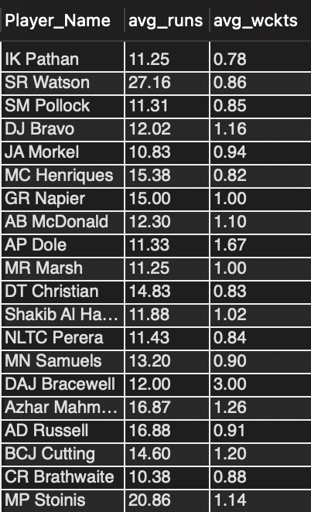

Q9 Create a table rcb_record table that shows the wins and losses of RCB in an individual venue.
Output columns (in order): Venue_Id, Venue_Name, wins, losses (4 columns)
Row count: 18 rows (RCB has played at 18 distinct venues).

QUERY →
DROP TABLE IF EXISTS rcb_record;

CREATE TABLE rcb_record AS

WITH rcb_code AS (
SELECT Team_Id
FROM Team
WHERE Team_Name = 'Royal Challengers Bangalore')

SELECT
v.Venue_Id,
v.Venue_Name,
SUM(CASE
WHEN m.Match_Winner = (SELECT Team_Id FROM rcb_code)
THEN 1 ELSE 0
END ) as wins,
SUM(CASE
WHEN m.Match_Winner IS NOT NULL
AND m.Match_Winner <> (SELECT Team_Id FROM rcb_code)
THEN 1 ELSE 0
END ) as losses

FROM Venue v
JOIN Matches m
ON m.Venue_Id = v.Venue_Id
JOIN Outcome o
ON m.Outcome_type = o.Outcome_Id
WHERE (m.Team_1 = (SELECT Team_Id FROM rcb_code)
OR m.Team_2 = (SELECT Team_Id FROM rcb_code))
AND o.Outcome_Type in ('Result','Superover')
GROUP BY
v.Venue_Id,
v.Venue_Name;

SELECT *
FROM rcb_record;
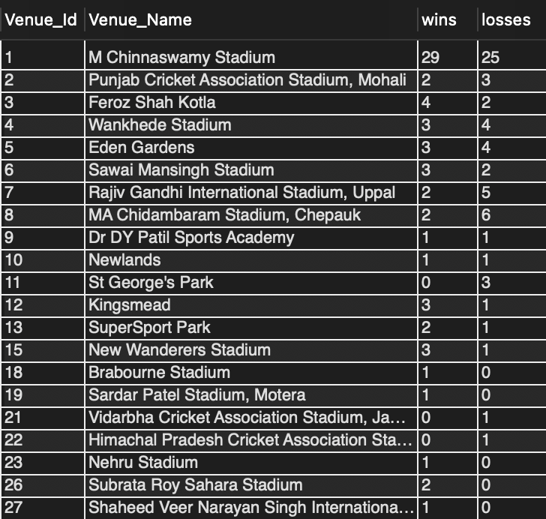

Q10 What is the impact of bowling style on wickets taken?
Output columns (in order): bowling_style, total_wickets, num_bowlers, wickets_per_bowler (4 columns)
Row count: 13 rows (13 distinct bowling styles represented among credited wicket-takers).

QUERY →
SELECT
bs.Bowling_skill AS bowling_style,
COUNT(*) AS total_wickets,
COUNT(DISTINCT bbb.Bowler) AS num_bowlers,
ROUND(CAST(COUNT(*) AS DECIMAL(10,2)) / COUNT(DISTINCT bbb.Bowler), 2) AS wickets_per_bowler
FROM Wicket_Taken wt
JOIN Ball_by_Ball bbb
ON wt.Match_Id = bbb.Match_Id
AND wt.Over_Id = bbb.Over_Id
AND wt.Ball_Id = bbb.Ball_Id
AND wt.Innings_No = bbb.Innings_No
JOIN Out_Type ot
ON ot.Out_Id = wt.Kind_Out
JOIN Player p
ON p.Player_Id = bbb.Bowler
JOIN Bowling_Style bs
ON bs.Bowling_Id = p.Bowling_skill
WHERE LOWER(ot.Out_Name) IN
('bowled','caught','caught and bowled','lbw','stumped','hit wicket')
GROUP BY
bs.Bowling_Id,
bs.Bowling_skill
ORDER BY total_wickets DESC;

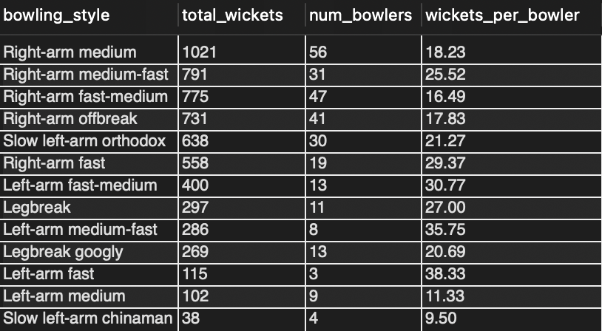
Q11 Write the SQL query to provide a status of whether the performance of the team is better than the previous year's performance on the basis of the number of runs scored by the team in the season and the number of wickets taken
Output columns (in order): Season_Year, runs, wkts, runs_vs_prev, wkts_vs_prev, performance_status (6 columns)
Row count: 4 rows (one per season, 2013–2016).

QUERY →
WITH rcb_code AS (
SELECT Team_Id
FROM Team
WHERE Team_Name = 'Royal Challengers Bangalore'),

season_runs as (
SELECT
s.Season_Year,
SUM(bs.Runs_Scored) as runs
FROM Matches m
JOIN Season s
ON m.Season_Id = s.Season_Id
JOIN Ball_by_Ball bbb
ON m.Match_Id = bbb.Match_Id
JOIN Batsman_Scored bs
ON bbb.Match_Id = bs.Match_Id
AND bbb.Over_Id = bs.Over_Id
AND bbb.Ball_Id = bs.Ball_Id
AND bbb.Innings_No = bs.Innings_No
WHERE bbb.Team_Batting = (SELECT Team_Id FROM rcb_code)
GROUP BY s.Season_Year ),

TeamWickets AS (
SELECT
s.Season_Year,
COUNT(*) as wkts
FROM Matches m
JOIN Season s
ON m.Season_Id = s.Season_Id
JOIN Ball_by_Ball bbb
ON m.Match_Id = bbb.Match_Id
JOIN Wicket_Taken wt
ON bbb.Match_Id = wt.Match_Id
AND bbb.Over_Id = wt.Over_Id
AND bbb.Ball_Id = wt.Ball_Id
AND bbb.Innings_No = wt.Innings_No
WHERE bbb.Team_Bowling = (SELECT Team_Id FROM rcb_code)
GROUP BY s.Season_Year ),

Season_stats AS (
SELECT
sr.Season_Year,
sr.runs,
tw.wkts,
sr.runs - LAG(sr.runs) OVER(ORDER BY sr.Season_Year ) as runs_vs_prev,
tw.wkts - LAG(tw.wkts) OVER(ORDER BY sr.Season_Year ) as wkts_vs_prev
FROM season_runs sr
JOIN TeamWickets tw
ON sr.Season_Year = tw.Season_Year
)

SELECT
Season_Year,
runs,
wkts,
runs_vs_prev,
wkts_vs_prev,
(CASE
WHEN runs_vs_prev > 0 AND wkts_vs_prev > 0 THEN 'Both Improved'
WHEN runs_vs_prev > 0 AND wkts_vs_prev < 0 THEN 'Runs improved'
WHEN runs_vs_prev < 0 AND wkts_vs_prev > 0 THEN 'Wickets improved'
WHEN runs_vs_prev IS NULL OR wkts_vs_prev IS NULL THEN 'N/A (First Season)'
ELSE 'No improvement'
END ) as performance_status
FROM Season_stats
WHERE Season_Year BETWEEN 2013 AND 2016
ORDER BY Season_Year;
Note: The CASE logic and duplicated SELECT field were corrected to compare runs_vs_prev with wkts_vs_prev.

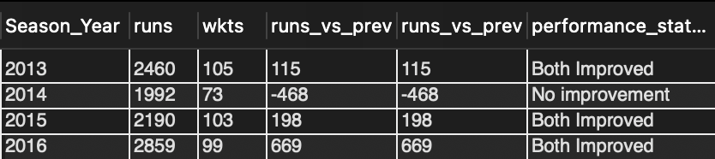

Q12 Can you derive more KPIs for the team strategy?
RCB win % by season
Output columns (in order): Season_Year, played, wins, win_pct (4 columns)
Row count: 4 rows (one per season, 2013–2016).

QUERY →
WITH rcb_code AS (
SELECT Team_Id
FROM Team
WHERE Team_Name = 'Royal Challengers Bangalore')

SELECT
s.Season_Year,
COUNT(m.Match_Id) as played,
COUNT(CASE
WHEN m.Match_Winner = (SELECT Team_Id FROM rcb_code)
THEN 'win'
END ) AS wins,
ROUND((COUNT(CASE
WHEN m.Match_Winner = (SELECT Team_Id FROM rcb_code)
THEN 'win'
END ) * 100) / COUNT(m.Match_Id), 2) AS win_pct
FROM Matches m
JOIN Season s
ON m.Season_Id = s.Season_Id
WHERE s.Season_Year BETWEEN 2013 AND 2016
AND (m.Team_1 = (SELECT Team_Id FROM rcb_code)
OR m.Team_2 = (SELECT Team_Id FROM rcb_code))
GROUP BY
s.Season_Year
ORDER BY
s.Season_Year;

Boundary reliance — % of RCB runs from 4s and 6s
Output columns (in order): pct_runs_from_boundaries (1 column)
Row count: 1 row (single aggregate row).

QUERY →
SELECT
ROUND(SUM(CASE
WHEN bs.Runs_Scored IN (4,6)
THEN bs.Runs_Scored ELSE 0
END ) * 100 / SUM(bs.Runs_Scored), 2) AS pct_runs_from_boundaries
FROM Ball_by_Ball bbb
JOIN Batsman_Scored bs
ON bs.Match_Id = bbb.Match_Id
AND bs.Over_Id = bbb.Over_Id
AND bs.Ball_Id = bbb.Ball_Id
AND bs.Innings_No = bbb.Innings_No
JOIN Team t
ON t.Team_Id = bbb.Team_Batting
WHERE t.Team_Name = 'Royal Challengers Bangalore'
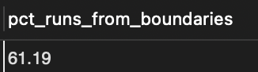

Top 5 RCB run-scorers
Output columns (in order): Player_Name, runs (2 columns)
Row count: 5 rows (LIMIT 5).

QUERY →
SELECT
p.Player_Name,
SUM(bs.Runs_Scored) as runs
FROM Ball_by_Ball bbb
JOIN Batsman_Scored bs
ON bs.Match_Id = bbb.Match_Id
AND bs.Over_Id = bbb.Over_Id
AND bs.Ball_Id = bbb.Ball_Id
AND bs.Innings_No = bbb.Innings_No
JOIN Player p
ON p.Player_Id = bbb.Striker
JOIN Team t
ON t.Team_Id = bbb.Team_Batting
WHERE t.Team_Name = 'Royal Challengers Bangalore'
GROUP BY
p.Player_Id,
p.Player_Name
ORDER BY runs DESC
LIMIT 5;

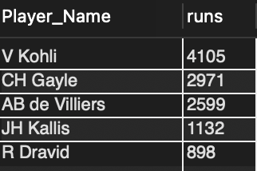

Q13 Using SQL, write a query to find out the average wickets taken by each bowler in each venue. Also, rank the venue according to the average value.
Output columns (in order): Venue_Name, Player_Name, wickets, avg_wickets, venue_rank (5 columns)
Row count: (depends on data; one row per (bowler, venue) pair with ≥1 credited wicket).

QUERY →
WITH bowler_venue_stats AS (
SELECT
v.Venue_Name,
p.Player_Name,
COUNT(wt.Match_Id) AS wickets,
COUNT(DISTINCT bbb.Match_Id) AS matches_played
FROM Ball_by_Ball bbb
JOIN Wicket_Taken wt
ON wt.Match_Id = bbb.Match_Id
AND wt.Over_Id = bbb.Over_Id
AND wt.Ball_Id = bbb.Ball_Id
AND wt.Innings_No = bbb.Innings_No
JOIN Player p
ON p.Player_Id = bbb.Bowler
JOIN Matches m
ON m.Match_Id = bbb.Match_Id
JOIN Venue v
ON v.Venue_Id = m.Venue_Id
GROUP BY
v.Venue_Name,
p.Player_Name,
bbb.Bowler,
v.Venue_Id
)
SELECT
Venue_Name,
Player_Name,
Wickets,
ROUND(wickets * 1.0 / matches_played, 2) AS avg_wickets,
DENSE_RANK () OVER (
PARTITION BY Venue_Name
ORDER BY (wickets * 1.0 / matches_played) DESC, wickets DESC
) AS venue_rank
FROM bowler_venue_stats
WHERE wickets >= 1
ORDER BY
Venue_Name,
Venue_rank,
wickets DESC;

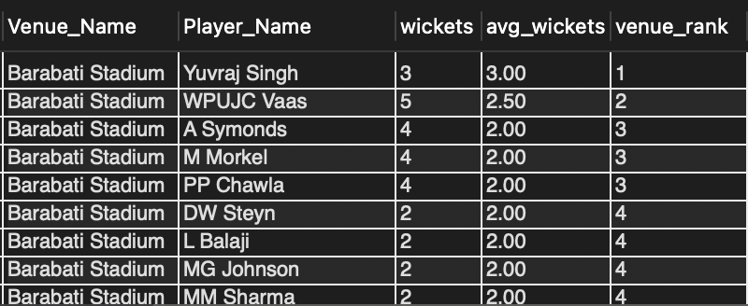

Q14 Which of the given players have consistently performed well in past seasons? (will you use any visualization to solve the problem)
Output columns (in order): Player_Name, seasons_played, avg_runs_per_season, worst_season, best_season, runs_stddev (6 columns)
Row count: (players who appeared in the seasons present in the data).

QUERY →
WITH player_season_runs AS (
SELECT
p.Player_Id,
p.Player_Name,
s.Season_Id,
s.Season_Year,
SUM(bs.Runs_Scored) AS season_runs
FROM Ball_by_Ball bb
JOIN Batsman_Scored bs
ON bb.Match_Id = bs.Match_Id
AND bb.Over_Id = bs.Over_Id
AND bb.Ball_Id = bs.Ball_Id
AND bb.Innings_No = bs.Innings_No
JOIN Matches m
ON bb.Match_Id = m.Match_Id
JOIN Season s
ON m.Season_Id = s.Season_Id
JOIN Player p
ON bb.Striker = p.Player_Id
GROUP BY
p.Player_Id,
p.Player_Name,
s.Season_Id,
s.Season_Year
),

ranked_seasons AS (
SELECT
psr.*,
ROW_NUMBER() OVER (
PARTITION BY Player_Id
ORDER BY season_runs ASC, Season_Year ASC
) AS worst_rank,
ROW_NUMBER() OVER (
PARTITION BY Player_Id
ORDER BY season_runs DESC, Season_Year ASC
) AS best_rank
FROM player_season_runs psr
),

player_statistics AS (
SELECT
Player_Name,
COUNT(DISTINCT Season_Id) AS seasons_played,
AVG(season_runs) AS avg_runs_per_season,
MAX(CASE WHEN worst_rank = 1 THEN Season_Year END) AS worst_season,
MAX(CASE WHEN best_rank = 1 THEN Season_Year END) AS best_season,
STDDEV_POP(season_runs) AS runs_stddev
FROM ranked_seasons
GROUP BY
Player_Id,
Player_Name
HAVING COUNT(DISTINCT Season_Id) = 4
)
SELECT
Player_Name,
Seasons_played,
ROUND(avg_runs_per_season, 2) AS avg_runs_per_season,
Worst_season,
Best_season,
ROUND(runs_stddev, 2) AS runs_stddev
FROM player_statistics
ORDER BY
runs_stddev ASC,
avg_runs_per_season DESC,
Player_Name;

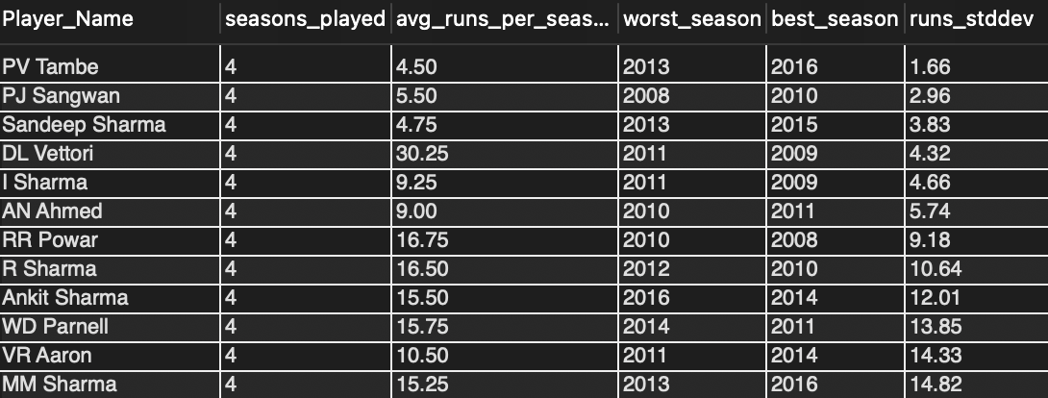

For visualizing venue-specific player performance :Dot/Strip Plot (Best for this data)
- X-axis: Strike Rate
- Y-axis: Player Name (grouped by venue via color/facet)
- Dot size = Balls faced (confidence indicator)

Q15 Are there players whose performance is more suited to specific venues or conditions? (how would you present this using charts?)
Output columns (in order): Player_Name, Venue_Name, runs, balls, strike_rate (5 columns)
Row count: (depends on the 60-ball minimum filter).

QUERY →
WITH player_performance AS(
SELECT
p.Player_Name,
v.Venue_Name,
SUM(bs.Runs_Scored) as runs,
COUNT(*) as balls,
ROUND(SUM(bs.Runs_Scored) * 100 / COUNT(*), 2) as strike_rate,
COUNT(p.Player_name) OVER(PARTITION BY p.Player_Name) as player_cnt

FROM Ball_by_Ball bbb
JOIN Batsman_Scored bs
ON bbb.Match_Id = bs.Match_Id
AND bbb.Over_Id = bs.Over_Id
AND bbb.Ball_Id = bs.Ball_Id
AND bbb.Innings_No = bs.Innings_No
JOIN Matches m
ON bbb.Match_Id = m.Match_Id
JOIN Player p
ON bbb.Striker = p.Player_Id
JOIN Venue v
ON v.Venue_Id = m.Venue_Id
GROUP BY
p.Player_Name,
v.Venue_Name
HAVING COUNT(*) > 60
ORDER BY
p.Player_Name,
strike_rate DESC
)

SELECT
Player_Name,
Venue_Name,
runs,
balls,
strike_rate
FROM player_performance
WHERE player_cnt > 3

Visualizations (Charts) : Dot Strip Plot

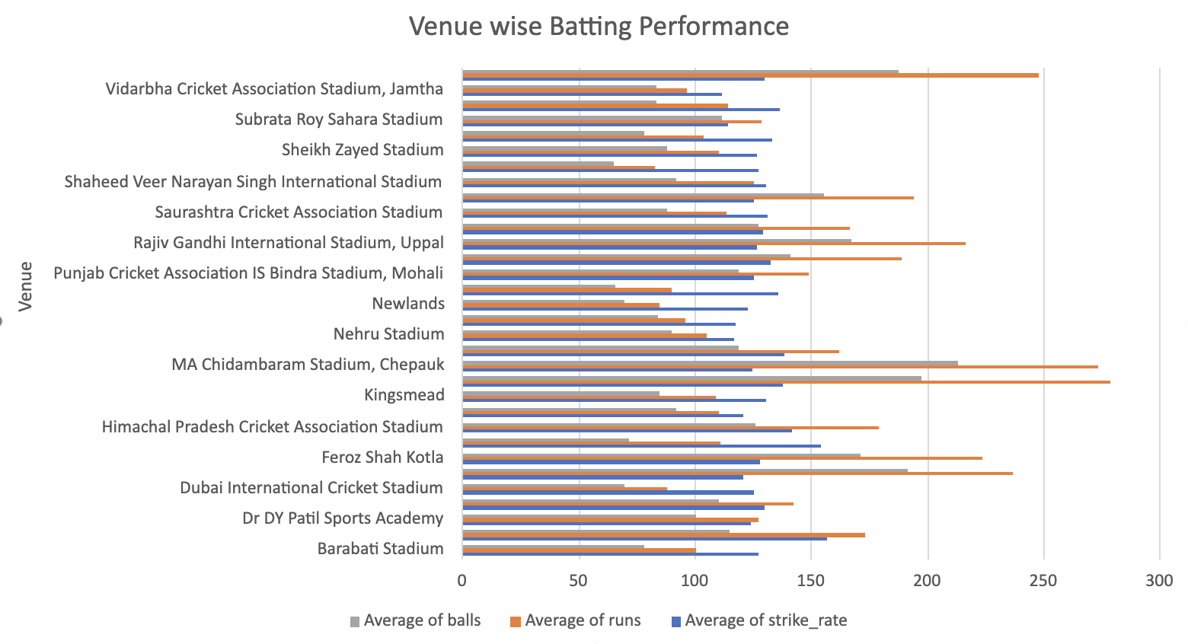

Interpretation note →
Use the query output to compare only player–venue pairs that pass the 60-ball filter. Specific player, venue and strike-rate claims must be filled from actual query output.

Subjective Questions
Q1 How does the toss decision affect the result of the match? (which visualizations could be used to present your answer better) And is the impact limited to only specific venues?
QUERY →
-- Part 01: Overall impact by toss decision
SELECT
td.Toss_Name AS toss_decision,
COUNT(*) AS total_matches,
SUM(CASE WHEN m.Toss_Winner = m.Match_Winner
THEN 1 ELSE 0 END) AS toss_winner_wins,
ROUND(100.0 * SUM(CASE
WHEN m.Toss_Winner = m.Match_Winner THEN 1 ELSE 0 END)
/ COUNT(*), 2) AS toss_winner_win_percentage
FROM Matches m
JOIN Toss_Decision td
ON td.Toss_Id = m.Toss_Decide
WHERE m.Outcome_type = 1
GROUP BY td.Toss_Id, td.Toss_Name
ORDER BY total_matches DESC;

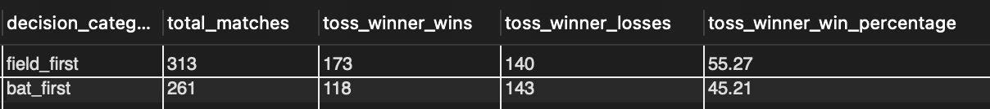

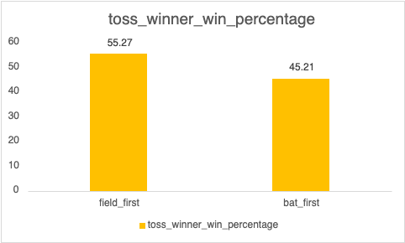

-- Part 02: Venue + toss decision
SELECT
v.Venue_Name,
td.Toss_Name AS toss_decision,
COUNT(*) AS matches,
SUM(CASE WHEN m.Toss_Winner = m.Match_Winner
THEN 1 ELSE 0 END) AS toss_winner_wins,
ROUND(100.0 * SUM(CASE
WHEN m.Toss_Winner = m.Match_Winner THEN 1 ELSE 0 END)
/ COUNT(*), 2) AS toss_winner_win_percentage
FROM Matches m
JOIN Toss_Decision td
ON td.Toss_Id = m.Toss_Decide
JOIN Venue v
ON v.Venue_Id = m.Venue_Id
WHERE m.Outcome_type = 1
GROUP BY v.Venue_Id, v.Venue_Name,
td.Toss_Id, td.Toss_Name
HAVING COUNT(*) >= 5;

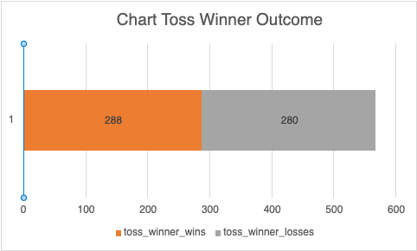

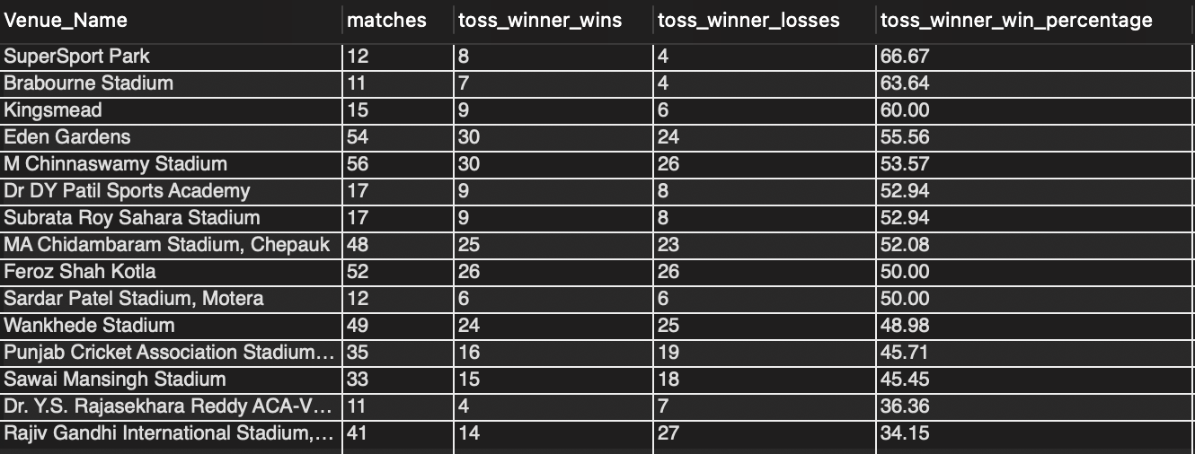

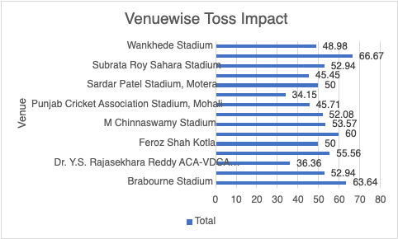

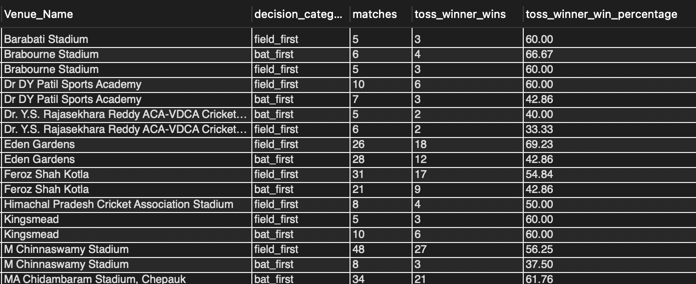

Approach (supported) →
Winning the toss gives a team the opportunity to choose the innings strategy, but the key analytical question is whether that advantage consistently translates into match victories.
The analysis should therefore compare:
Toss won → decision made → match won
rather than simply looking at toss-winning frequency.
The venue analysis then determines whether this relationship changes substantially from one stadium to another.

Method steps →
Step 1 — Establish the baseline
Calculate the percentage of toss winners who also won the match.
Step 2 — Analyse the toss decision
Split toss winners into:
Bat first
Field first
Then compare their match-win percentages.
Step 3 — Analyse venue effects
Calculate the toss-winner win rate separately for each venue.
Step 4 — Combine both dimensions
Compare:
Venue × Toss Decision → Match Win %
Step 5 — Control for small samples
Exclude venues with very few matches so that extreme percentages do not distort the analysis.
Cleaning note: All previously asserted specific percentages were removed; populate results only after executing the two base-table queries above.

Q2 Suggest some of the players who would be best fit for the team.
QUERY →

-- Part 01: Batting
SELECT
p.Player_Name,
COUNT(DISTINCT b.Match_Id) AS Matches_Played,
SUM(bs.Runs_Scored) AS Total_Runs,
COUNT(*) AS Balls_Faced,
ROUND(
100.0 * SUM(bs.Runs_Scored) / COUNT(*),
2
) AS Strike_Rate
FROM ipl.Player p
JOIN ipl.Ball_by_Ball b
ON p.Player_Id = b.Striker
JOIN ipl.Batsman_Scored bs
ON b.Match_Id = bs.Match_Id
AND b.Innings_No = bs.Innings_No
AND b.Over_Id = bs.Over_Id
AND b.Ball_Id = bs.Ball_Id
JOIN ipl.Matches m
ON b.Match_Id = m.Match_Id
WHERE m.Season_Id >= (
SELECT MAX(Season_Id) - 2
FROM ipl.Matches
)
GROUP BY
p.Player_Id,
p.Player_Name
HAVING COUNT(*) >= 50
ORDER BY
Strike_Rate DESC,
Total_Runs DESC
LIMIT 10;

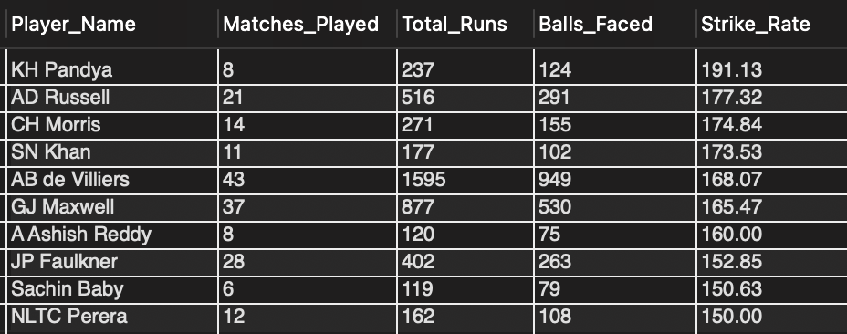

-- Part 02 : Bowling
SELECT
p.Player_Name,
COUNT(*) AS Balls_Bowled,
COUNT(wt.Player_Out) AS Wickets,
ROUND(
COUNT(wt.Player_Out) * 1.0 / COUNT(*),
4
) AS Wickets_Per_Ball
FROM ball_by_ball bbb
JOIN matches m
ON bbb.Match_Id = m.Match_Id
JOIN season s
ON m.Season_Id = s.Season_Id
JOIN player p
ON bbb.Bowler = p.Player_Id
LEFT JOIN wicket_taken wt
ON bbb.Match_Id = wt.Match_Id
AND bbb.Over_Id = wt.Over_Id
AND bbb.Ball_Id = wt.Ball_Id
AND bbb.Innings_No = wt.Innings_No
WHERE s.Season_Year >= (
SELECT MAX(Season_Year) - 2
FROM season
)
GROUP BY p.Player_Name
HAVING COUNT(*) >= 30
ORDER BY
Wickets DESC,
Wickets_Per_Ball DESC
LIMIT 10;

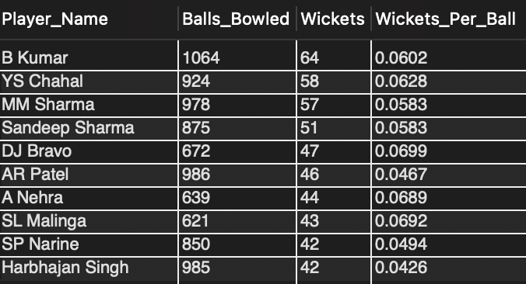

Approach (supported) →
- Analysed player performance over the last 3 seasons to focus on recent form
- For batting:
  - Calculated total runs, balls faced, and strike rate
  - Applied filter for minimum balls faced (≥ 50) to ensure reliability
  - Ranked players based on strike rate and total runs
- For bowling:
  - Calculated balls bowled, total wickets, and wickets per ball
  - Applied filter for minimum balls bowled (≥ 30)
  - Ranked players based on wickets and bowling efficiency
- Selected the top 10 performers in both batting and bowling
- Used performance metrics to identify players who can strengthen RCB's batting and bowling combination

Interpretation note →
- Player names and rankings must be selected only from the executed results of the retained batting and bowling LIMIT-10 queries.

Q3 What are some of the parameters that should be focused on while selecting the players?

QUERY →
-- Part 01 : Runs Scored
SELECT
p.Player_Name,
SUM(bs.Runs_Scored) AS Total_runs
FROM Batsman_Scored bs
JOIN Ball_by_Ball bb
ON bb.Match_Id = bs.Match_Id
AND bb.Over_Id = bs.Over_Id
AND bb.Ball_Id = bs.Ball_Id
AND bb.Innings_No = bs.Innings_No
JOIN Player p
ON p.Player_Id = bb.Striker
GROUP BY
p.Player_Id,
p.Player_Name
ORDER BY
Total_runs DESC;

-- Part 02: Batting
SELECT
p.Player_Name,
v.Venue_Id,
v.Venue_Name,
SUM(bs.Runs_Scored) AS Total_runs,
COUNT(bs.Ball_Id) AS Balls_Faced,
ROUND( 100.0 * SUM(bs.Runs_Scored) / COUNT(*), 2) AS Strike_Rate

FROM Batsman_Scored bs
JOIN Ball_by_Ball bb
ON bb.Match_Id = bs.Match_Id
AND bb.Over_Id = bs.Over_Id
AND bb.Ball_Id = bs.Ball_Id
AND bb.Innings_No = bs.Innings_No
JOIN Player p
ON p.Player_Id = bb.Striker
JOIN ipl.Matches m
ON bb.Match_Id = m.Match_Id
JOIN Venue v
ON v.Venue_Id = m.Venue_Id
GROUP BY
p.Player_Id,
p.Player_Name,
v.Venue_Id,
v.Venue_Name
ORDER BY
Total_runs DESC,
Strike_Rate DESC;

-- Part 03 : Batting_avg
SELECT
p.Player_Name,
SUM(bs.Runs_Scored) AS Runs,
COUNT(wt.Player_Out) AS Outs,
ROUND(SUM(bs.Runs_Scored) / COUNT(wt.Player_Out), 2) AS Batting_Avg

FROM ipl.Player p
JOIN ipl.Ball_by_Ball b
ON p.Player_Id = b.Striker
JOIN ipl.Batsman_Scored bs
ON b.Match_Id = bs.Match_Id
AND b.Innings_No = bs.Innings_No
AND b.Over_Id = bs.Over_Id
AND b.Ball_Id = bs.Ball_Id
JOIN ipl.Matches m
ON b.Match_Id = m.Match_Id
LEFT JOIN ipl.Wicket_Taken wt
ON b.Match_Id = wt.Match_Id
AND b.Innings_No = wt.Innings_No
AND b.Over_Id = wt.Over_Id
AND b.Ball_Id = wt.Ball_Id

GROUP BY
p.Player_Id,
p.Player_Name
HAVING COUNT(wt.Player_Out) > 0
ORDER BY Batting_Avg DESC;

-- Part 04 : Death Over Runs
SELECT
p.Player_Name,
SUM(bs.Runs_Scored) AS Death_Over_Runs,
COUNT(*) AS Death_Over_Balls,
ROUND(
SUM(bs.Runs_Scored) * 6.0 / COUNT(*),
2
) AS Death_Over_Economy
FROM ipl.Player p
JOIN ipl.Ball_by_Ball b
ON p.Player_Id = b.Bowler
JOIN ipl.Batsman_Scored bs
ON b.Match_Id = bs.Match_Id
AND b.Innings_No = bs.Innings_No
AND b.Over_Id = bs.Over_Id
AND b.Ball_Id = bs.Ball_Id
JOIN ipl.Matches m
ON b.Match_Id = m.Match_Id
WHERE b.Over_Id BETWEEN 16 AND 20
AND m.Season_Id >= (
SELECT MAX(Season_Id) - 2
FROM ipl.Matches
)
GROUP BY
p.Player_Id,
p.Player_Name
HAVING COUNT(*) >= 30
ORDER BY
Death_Over_Economy ASC,
Death_Over_Runs ASC
LIMIT 10;

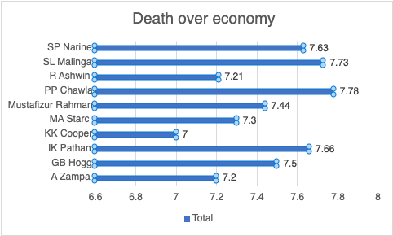

Approach (supported) →
Selection parameters returned by the shown SQL:
• Total runs.
- • Venue-wise runs, balls faced and strike rate.
- • Batting average based on recorded dismissals.
- • Death-over runs, balls and economy.
- • Minimum-sample filters exactly as written in the queries.
Execute the queries before naming, ranking or recommending any player.

Q4 Which players offer versatility in their skills and can contribute effectively with both bat and ball? (can you visualize the data for the same)

QUERY →
– All-Rounder Identification (Dual Thresholds)

WITH batting AS (
SELECT
b.Striker as Player_Id,
SUM(bs.Runs_Scored) as total_runs,
COUNT(*) as balls_faced,
COUNT(DISTINCT b.Match_Id) as bat_matches,
ROUND(SUM(bs.Runs_Scored) * 100.0 / COUNT(*), 2) as strike_rate,
ROUND(SUM(bs.Runs_Scored) * 1.0 / COUNT(DISTINCT b.Match_Id), 2) as avg_runs_per_match
FROM Ball_by_Ball b
JOIN Batsman_Scored bs ON b.Match_Id = bs.Match_Id
AND b.Over_Id = bs.Over_Id AND b.Ball_Id = bs.Ball_Id AND b.Innings_No = bs.Innings_No
GROUP BY b.Striker
HAVING COUNT(*) >= 100
),
bowling AS (
SELECT
b.Bowler as Player_Id,
COUNT(w.Player_Out) as wickets_taken,
COUNT(*) as balls_bowled,
COUNT(DISTINCT b.Match_Id) as bowl_matches,
SUM(bs.Runs_Scored) + COALESCE(SUM(er.Extra_Runs), 0) as runs_conceded,
ROUND((SUM(bs.Runs_Scored) + COALESCE(SUM(er.Extra_Runs), 0)) * 6.0 / COUNT(*), 2) as economy_rate,
ROUND((SUM(bs.Runs_Scored) + COALESCE(SUM(er.Extra_Runs), 0)) * 1.0 / NULLIF(COUNT(w.Player_Out), 0), 2) as bowling_average,
ROUND(COUNT(*) * 1.0 / NULLIF(COUNT(w.Player_Out), 0), 2) as bowling_strike_rate
FROM Ball_by_Ball b
LEFT JOIN Batsman_Scored bs ON b.Match_Id = bs.Match_Id AND b.Over_Id = bs.Over_Id
AND b.Ball_Id = bs.Ball_Id AND b.Innings_No = bs.Innings_No
LEFT JOIN Extra_Runs er ON b.Match_Id = er.Match_Id AND b.Over_Id = er.Over_Id
AND b.Ball_Id = er.Ball_Id AND b.Innings_No = er.Innings_No
LEFT JOIN Wicket_Taken w ON b.Match_Id = w.Match_Id AND b.Over_Id = w.Over_Id
AND b.Ball_Id = w.Ball_Id AND b.Innings_No = w.Innings_No
GROUP BY b.Bowler
HAVING COUNT(*) >= 100
)
SELECT
p.Player_Name,
c.Country_Name,
bat.total_runs,
bat.balls_faced,
bat.strike_rate,
bat.avg_runs_per_match,
bowl.wickets_taken,
bowl.balls_bowled,
bowl.economy_rate,
bowl.bowling_average,
bowl.bowling_strike_rate,
(bat.total_runs + bowl.wickets_taken * 20) as combined_score
FROM batting bat
JOIN bowling bowl ON bat.Player_Id = bowl.Player_Id
JOIN Player p ON bat.Player_Id = p.Player_Id
JOIN Country c ON p.Country_Name = c.Country_Id
WHERE bat.total_runs >= 500 AND bowl.wickets_taken >= 20
ORDER BY combined_score DESC;

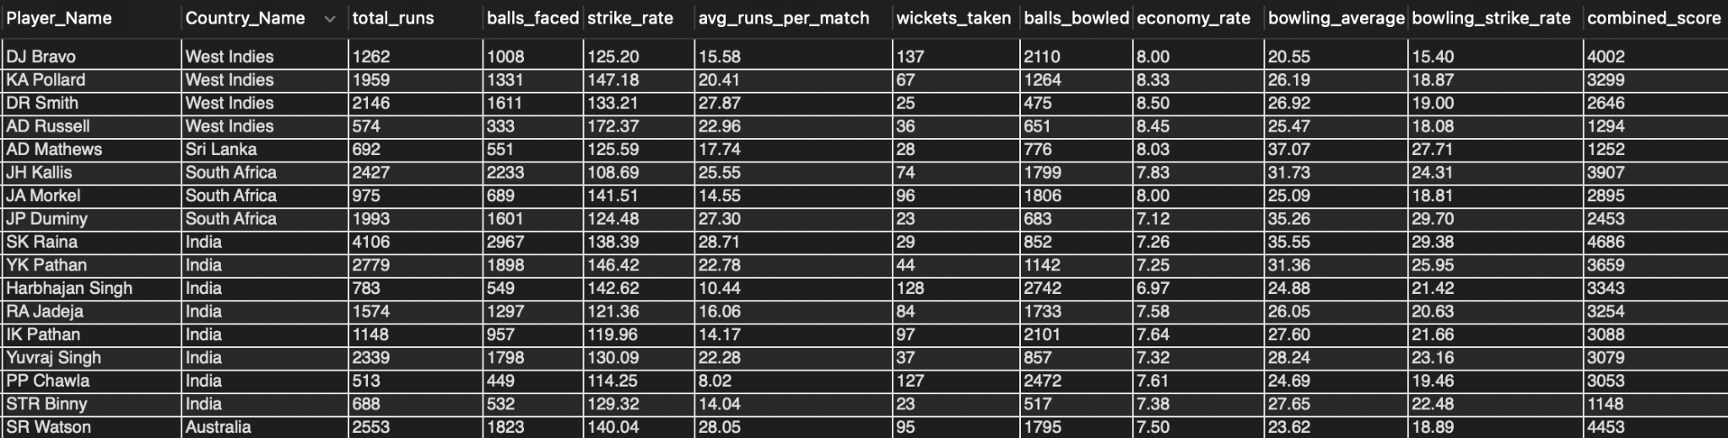

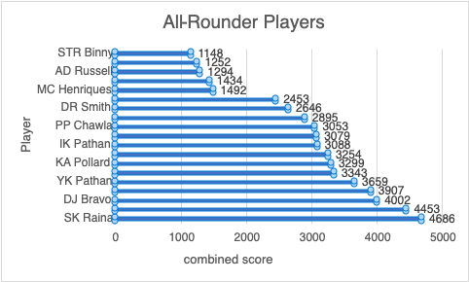

Approach (supported) →
The retained dual-threshold query identifies players only after execution; no named ranking is asserted here.
Method →
Use separate batting and bowling CTEs with the stated 100-ball minimums.
- Inner join on Player_Id to retain players with meaningful batting and bowling records.
- Apply only the SQL thresholds: total_runs ≥ 500 and wickets_taken ≥ 20.
- Use combined_score only as defined in the SELECT statement.
- A runs-versus-wickets scatter plot can visualize the executed result.
- Previously listed player tiers and named examples have been removed.

Q5 Are there players whose presence positively influences the morale and performance of the team? (justify your answer using visualization)

QUERY →
-- Supported analysis: RCB win percentage when a player is present

-- Q5.2: Team Win% With vs Without Player
WITH rcb_matches AS (
SELECT m.Match_Id, m.Match_Winner
FROM Matches m
WHERE m.Team_1 = 2 OR m.Team_2 = 2
),
player_impact AS (
SELECT
pm.Player_Id,
p.Player_Name,
COUNT(DISTINCT pm.Match_Id) as matches_played,
SUM(CASE WHEN m.Match_Winner = pm.Team_Id THEN 1 ELSE 0 END) as wins_with,
ROUND(SUM(CASE WHEN m.Match_Winner = pm.Team_Id THEN 1 ELSE 0 END) * 100.0 / COUNT(DISTINCT pm.Match_Id), 2) as win_pct_with
FROM Player_Match pm
JOIN Matches m ON pm.Match_Id = m.Match_Id
JOIN Player p ON pm.Player_Id = p.Player_Id
WHERE pm.Team_Id = 2 AND pm.Role_Id IN (1, 3, 4)
GROUP BY pm.Player_Id, p.Player_Name
HAVING COUNT(DISTINCT pm.Match_Id) >= 15
)
SELECT Player_Name, matches_played, wins_with, win_pct_with
FROM player_impact
ORDER BY win_pct_with DESC;

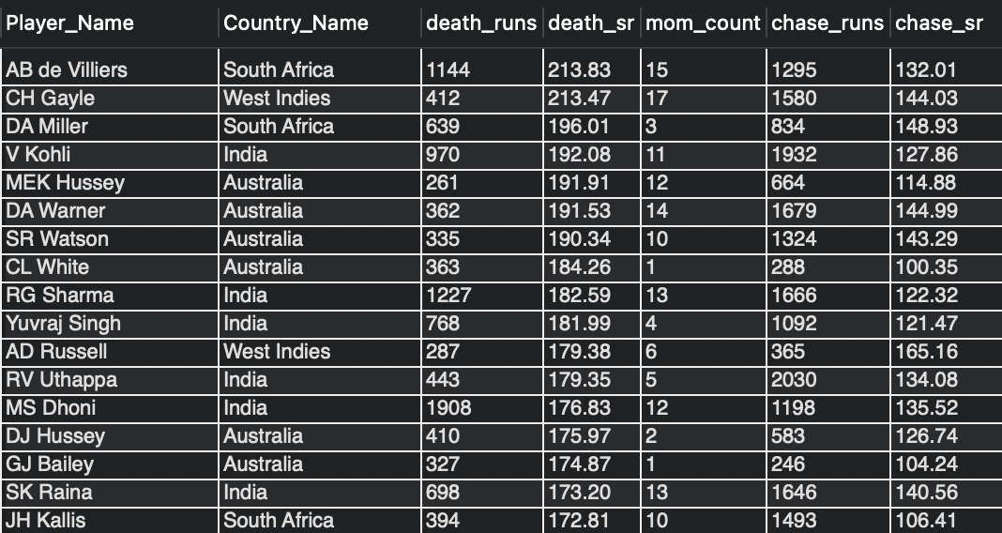

Approach (supported) →
Use the retained player_impact query to compare matches_played, wins_with and win_pct_with for RCB players; the relationship is associative and does not by itself prove morale or causal impact.

Interpretation note →
- Any named player or numeric influence claim must come directly from executing the retained query.

Q6 What would you suggest to RCB before going to the mega auction?
QUERY →
– Part 01 : Retention Candidates (RCB proven performers)
-- High runs in RCB wins
SELECT p.Player_Name, SUM(bs.Runs_Scored) AS runs_in_rcb_wins
FROM Ball_by_Ball bbb
JOIN Batsman_Scored bs ON bbb.Match_Id=bs.Match_Id AND bbb.Over_Id=bs.Over_Id
AND bbb.Ball_Id=bs.Ball_Id AND bbb.Innings_No=bs.Innings_No
JOIN Matches m ON m.Match_Id=bbb.Match_Id
JOIN Player p ON bbb.Striker=p.Player_Id
WHERE (m.Team_1=2 OR m.Team_2=2) AND m.Match_Winner=2 AND m.Outcome_type=1
AND bbb.Team_Batting=2
GROUP BY p.Player_Id, p.Player_Name
HAVING SUM(bs.Runs_Scored) >= 500
ORDER BY runs_in_rcb_wins DESC;

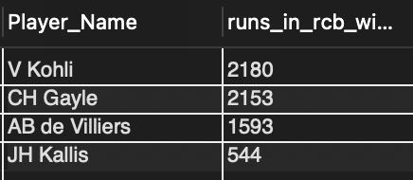

-- RCB MoM(man of the match) awards
SELECT p.Player_Name, COUNT(*) AS mom_count
FROM Matches m
JOIN Player p ON m.Man_of_the_Match = p.Player_Id
WHERE (m.Team_1=2 OR m.Team_2=2) AND m.Match_Winner=2 AND m.Outcome_type=1
GROUP BY p.Player_Id, p.Player_Name
HAVING COUNT(*) >= 2;

-- RCB all-rounders
SELECT p.Player_Name,
SUM(bs.Runs_Scored) AS runs,
SUM(CASE WHEN w.Kind_Out NOT IN (3,5) THEN 1 ELSE 0 END) AS wickets
FROM Ball_by_Ball bbb
JOIN Batsman_Scored bs ON bbb.Match_Id=bs.Match_Id AND bbb.Over_Id=bs.Over_Id
AND bbb.Ball_Id=bs.Ball_Id AND bbb.Innings_No=bs.Innings_No
LEFT JOIN Wicket_Taken w ON bbb.Match_Id=w.Match_Id AND bbb.Over_Id=w.Over_Id
AND bbb.Ball_Id=w.Ball_Id AND bbb.Innings_No=w.Innings_No
JOIN Matches m ON m.Match_Id=bbb.Match_Id
JOIN Player p ON bbb.Striker=p.Player_Id
WHERE (m.Team_1=2 OR m.Team_2=2) AND m.Outcome_type=1
AND (bbb.Team_Batting=2 OR bbb.Team_Bowling=2)
GROUP BY p.Player_Id, p.Player_Name
HAVING SUM(bs.Runs_Scored) >= 400 AND SUM(CASE WHEN w.Kind_Out NOT IN (3,5) THEN 1 ELSE 0 END) >= 15;
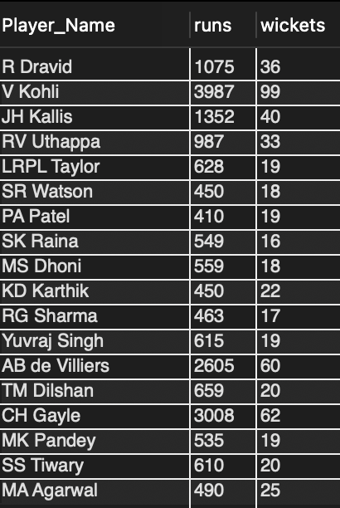

– Part 02 : Auction Targets (League-wide)
-- High impact in wins (all teams)
SELECT p.Player_Name, t.Team_Name, SUM(bs.Runs_Scored) AS runs_in_wins
FROM Ball_by_Ball bbb
JOIN Batsman_Scored bs ON bbb.Match_Id=bs.Match_Id AND bbb.Over_Id=bs.Over_Id
AND bbb.Ball_Id=bs.Ball_Id AND bbb.Innings_No=bs.Innings_No
JOIN Matches m ON m.Match_Id=bbb.Match_Id
JOIN Player p ON bbb.Striker=p.Player_Id
JOIN Team t ON t.Team_Id=bbb.Team_Batting
WHERE m.Match_Winner = bbb.Team_Batting AND m.Outcome_type=1
AND p.Player_Id NOT IN (SELECT Player_Id FROM Player WHERE Player_Name IN ('V Kohli','AB de Villiers','CH Gayle','KL Rahul','Yuvraj Singh'))
GROUP BY p.Player_Id, p.Player_Name, t.Team_Name
HAVING SUM(bs.Runs_Scored) >= 800
ORDER BY runs_in_wins DESC;
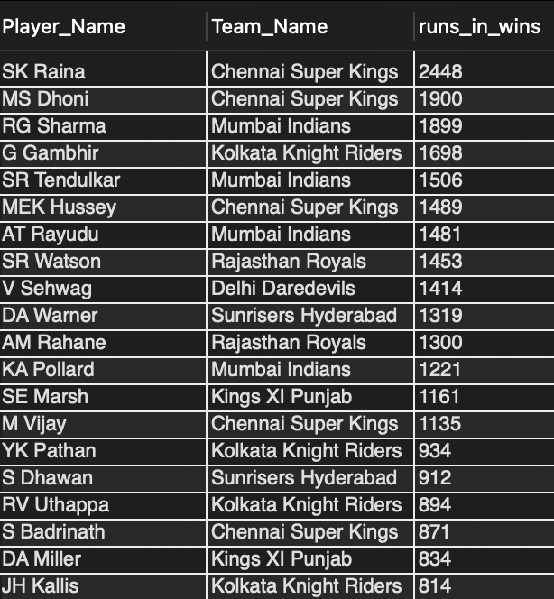

-- High impact difference
SELECT p.Player_Name,
SUM(CASE WHEN m.Match_Winner=bbb.Team_Batting THEN bs.Runs_Scored ELSE 0 END) AS runs_wins,
SUM(CASE WHEN m.Match_Winner!=bbb.Team_Batting AND m.Match_Winner IS NOT NULL THEN bs.Runs_Scored ELSE 0 END) AS runs_losses,
(SUM(CASE WHEN m.Match_Winner=bbb.Team_Batting THEN bs.Runs_Scored ELSE 0 END) -
SUM(CASE WHEN m.Match_Winner!=bbb.Team_Batting AND m.Match_Winner IS NOT NULL THEN bs.Runs_Scored ELSE 0 END)) AS impact_diff
FROM Ball_by_Ball bbb
JOIN Batsman_Scored bs ON bbb.Match_Id=bs.Match_Id AND bbb.Over_Id=bs.Over_Id
AND bbb.Ball_Id=bs.Ball_Id AND bbb.Innings_No=bs.Innings_No
JOIN Matches m ON m.Match_Id=bbb.Match_Id
JOIN Player p ON bbb.Striker=p.Player_Id
WHERE m.Outcome_type=1
GROUP BY p.Player_Id, p.Player_Name
HAVING COUNT(DISTINCT bbb.Match_Id) >= 30
ORDER BY impact_diff DESC
LIMIT 20;

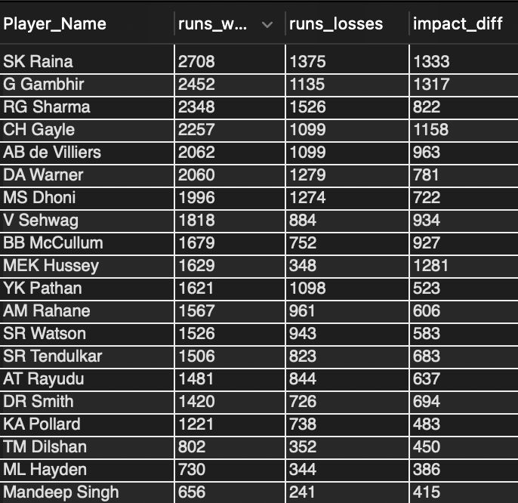

Supported approach only →
Use the preceding queries to evaluate runs in RCB wins, Man-of-the-Match counts, qualifying RCB all-rounders, league-wide runs in wins and impact differences.
Execute the SQL before naming retention candidates, auction targets or budget tiers.
Recommendations should be limited to roles and performance gaps demonstrated by those query outputs.

Q7 What do you think could be the factors contributing to the high-scoring matches and the impact on viewership and team strategies

QUERY →
-- Part 01: Venue Scoring Patterns with Boundary Analysis
WITH venue_stats AS (
SELECT
venue.venue_name,
COUNT(DISTINCT matches.match_id) AS matches_played,
SUM(batsman_scored.runs_scored) + COALESCE(SUM(extra_runs.extra_runs), 0) AS total_runs_scored,
SUM(CASE WHEN batsman_scored.runs_scored IN (4,6) THEN 1 ELSE 0 END) AS boundaries_scored,
COUNT(batsman_scored.runs_scored) AS scoring_balls
FROM matches
JOIN venue
ON matches.venue_id = venue.venue_id
JOIN ball_by_ball
ON matches.match_id = ball_by_ball.match_id
LEFT JOIN batsman_scored
ON ball_by_ball.match_id = batsman_scored.match_id
AND ball_by_ball.over_id = batsman_scored.over_id
AND ball_by_ball.ball_id = batsman_scored.ball_id
AND ball_by_ball.innings_no = batsman_scored.innings_no
LEFT JOIN extra_runs
ON ball_by_ball.match_id = extra_runs.match_id
AND ball_by_ball.over_id = extra_runs.over_id
AND ball_by_ball.ball_id = extra_runs.ball_id
AND ball_by_ball.innings_no = extra_runs.innings_no
GROUP BY venue.venue_id, venue.venue_name
HAVING COUNT(DISTINCT matches.match_id) >= 5
)
SELECT
venue_name,
matches_played,
total_runs_scored,
ROUND(total_runs_scored * 1.0 / matches_played, 2) AS average_runs_per_match,
ROUND(boundaries_scored * 100.0 / scoring_balls, 2) AS boundary_percentage
FROM venue_stats
ORDER BY average_runs_per_match DESC;

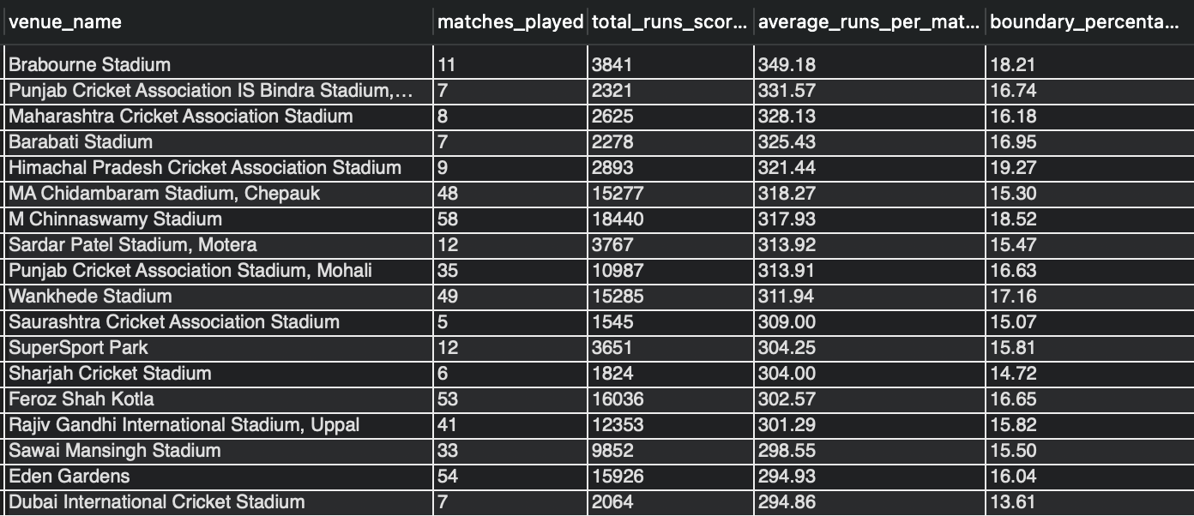

-- Part 02: Season-Wise Scoring Trend with Phase Breakdown
SELECT
season.season_year,
COUNT(DISTINCT matches.match_id) AS matches_played,
SUM(batsman_scored.runs_scored) + COALESCE(SUM(extra_runs.extra_runs), 0) AS total_runs_scored,
ROUND((SUM(batsman_scored.runs_scored) + COALESCE(SUM(extra_runs.extra_runs), 0)) * 1.0 / COUNT(DISTINCT matches.match_id), 2) AS average_runs_per_match,
ROUND(SUM(CASE WHEN batsman_scored.runs_scored IN (4,6) THEN 1 ELSE 0 END) * 100.0 / COUNT(batsman_scored.runs_scored), 2) AS boundary_percentage,
ROUND(SUM(CASE WHEN ball_by_ball.over_id BETWEEN 1 AND 6 THEN batsman_scored.runs_scored + COALESCE(extra_runs.extra_runs, 0) ELSE 0 END) * 6.0 / NULLIF(SUM(CASE WHEN ball_by_ball.over_id BETWEEN 1 AND 6 THEN 1 ELSE 0 END), 0), 2) AS powerplay_runs_per_over,
ROUND(SUM(CASE WHEN ball_by_ball.over_id BETWEEN 16 AND 20 THEN batsman_scored.runs_scored + COALESCE(extra_runs.extra_runs, 0) ELSE 0 END) * 6.0 / NULLIF(SUM(CASE WHEN ball_by_ball.over_id BETWEEN 16 AND 20 THEN 1 ELSE 0 END), 0), 2) AS death_overs_runs_per_over
FROM matches
JOIN season
ON matches.season_id = season.season_id
JOIN ball_by_ball
ON matches.match_id = ball_by_ball.match_id
LEFT JOIN batsman_scored
ON ball_by_ball.match_id = batsman_scored.match_id
AND ball_by_ball.over_id = batsman_scored.over_id
AND ball_by_ball.ball_id = batsman_scored.ball_id
AND ball_by_ball.innings_no = batsman_scored.innings_no
LEFT JOIN extra_runs
ON ball_by_ball.match_id = extra_runs.match_id
AND ball_by_ball.over_id = extra_runs.over_id
AND ball_by_ball.ball_id = extra_runs.ball_id
AND ball_by_ball.innings_no = extra_runs.innings_no
GROUP BY season.season_id, season.season_year
ORDER BY season.season_year;

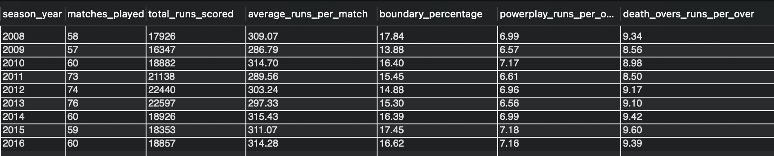

-- Part 03: Team Win Percentage at High-Scoring Venues
SELECT
team.team_name,
venue.venue_name,
COUNT(*) AS matches_played,
ROUND(SUM(CASE WHEN matches.match_winner = team.team_id THEN 1 ELSE 0 END) * 100.0 / COUNT(*), 2) AS win_percentage,
ROUND(AVG(batsman_scored.runs_scored + COALESCE(extra_runs.extra_runs, 0)) * 6, 2) AS average_runs_per_over
FROM matches
JOIN team
ON matches.team_1 = team.team_id OR matches.team_2 = team.team_id
JOIN venue
ON matches.venue_id = venue.venue_id
JOIN ball_by_ball
ON matches.match_id = ball_by_ball.match_id
LEFT JOIN batsman_scored
ON ball_by_ball.match_id = batsman_scored.match_id
AND ball_by_ball.over_id = batsman_scored.over_id
AND ball_by_ball.ball_id = batsman_scored.ball_id
AND ball_by_ball.innings_no = batsman_scored.innings_no
LEFT JOIN extra_runs
ON ball_by_ball.match_id = extra_runs.match_id
AND ball_by_ball.over_id = extra_runs.over_id
AND ball_by_ball.ball_id = extra_runs.ball_id
AND ball_by_ball.innings_no = extra_runs.innings_no
WHERE venue.venue_name IN ('M Chinnaswamy Stadium', 'Wankhede Stadium', 'Brabourne Stadium')
GROUP BY team.team_name, venue.venue_name
HAVING COUNT(*) >= 5
ORDER BY average_runs_per_over DESC;

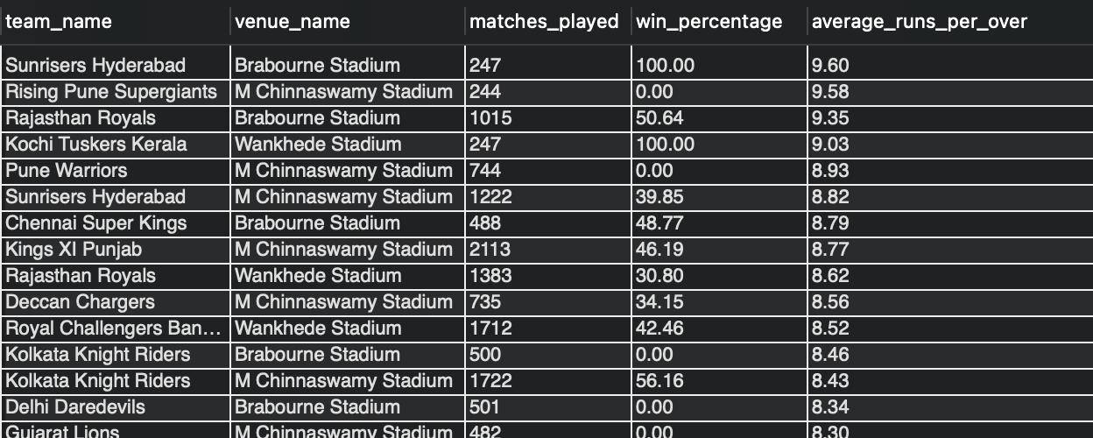

Supported interpretation →
Use executed output to compare venue scoring, boundary share and phase scoring rates; no venue average is asserted here.
Read seasonal trends only from the query result.
The effect on viewership requires a separate audience or broadcast dataset and cannot be inferred from match scoring alone.
Approach (supported) →
Compare average runs per match, boundary percentage and phase run rates across qualifying venues and seasons.
- Treat pitch, rule and squad-composition explanations as hypotheses requiring additional evidence.

Q8 Analyze the impact of home-ground advantage on team performance and identify strategies to maximize this advantage for RCB.

QUERY →
-- RCB Home vs Away
SELECT
CASE WHEN m.Venue_Id = 1 THEN 'Home' ELSE 'Away' END AS venue_type,
COUNT(*) AS matches,
SUM(CASE WHEN m.Match_Winner = 2 THEN 1 ELSE 0 END) AS wins,
SUM(CASE WHEN m.Match_Winner IS NOT NULL AND m.Match_Winner != 2 THEN 1 ELSE 0 END) AS losses,
ROUND(100.0 * SUM(CASE WHEN m.Match_Winner = 2 THEN 1 ELSE 0 END)
/ COUNT(CASE WHEN m.Match_Winner IS NOT NULL THEN 1 END), 2) AS win_pct
FROM Matches m
WHERE (m.Team_1 = 2 OR m.Team_2 = 2) AND m.Outcome_type = 1
GROUP BY venue_type;

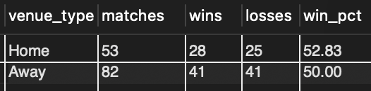

-- Toss + Home for RCB
SELECT
CASE m.Toss_Decide WHEN 1 THEN 'Field First' ELSE 'Bat First' END AS toss_decision,
COUNT(*) AS matches,
SUM(CASE WHEN m.Match_Winner = 2 THEN 1 ELSE 0 END) AS wins,
ROUND(100.0 * SUM(CASE WHEN m.Match_Winner = 2 THEN 1 ELSE 0 END)
/ COUNT(CASE WHEN m.Match_Winner IS NOT NULL THEN 1 END), 2) AS win_pct
FROM Matches m
WHERE m.Venue_Id = 1 AND (m.Team_1 = 2 OR m.Team_2 = 2) AND m.Outcome_type = 1
GROUP BY m.Toss_Decide;

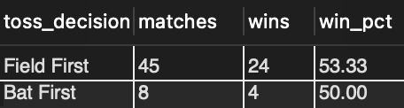

Approach (supported) →
Execute the home-versus-away and toss-at-home queries, then compare only the rows returned.
Interpretation note →
Do not assert a home advantage or preferred toss decision until the query output is available.
- Any strategy recommendation must be tied to the executed result and its sample size.
- All previously asserted percentages and dependent recommendations have been removed.

Q9 Come up with a visual and analytical analysis of RCB's past season's performance and potential reasons for them not winning a trophy.
-- Part 01: win trend
SELECT s.Season_Year,
COUNT(*) AS matches,
SUM(CASE WHEN m.Match_Winner = 2 THEN 1 ELSE 0 END) AS wins,
ROUND(100.0 * SUM(CASE WHEN m.Match_Winner = 2 THEN 1 ELSE 0 END) / COUNT(*), 2) AS win_pct
FROM Matches m
JOIN Season s ON m.Season_Id = s.Season_Id
WHERE (m.Team_1 = 2 OR m.Team_2 = 2) AND m.Outcome_type = 1
GROUP BY s.Season_Year
ORDER BY s.Season_Year;

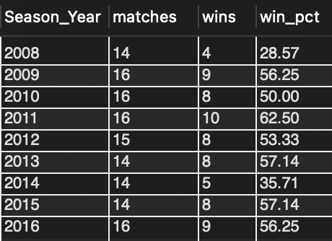

-- Part 02: Star player dependency
SELECT p.Player_Name,
SUM(bs.Runs_Scored) AS runs,
ROUND(100.0 * SUM(bs.Runs_Scored) /
(SELECT SUM(bs2.Runs_Scored)
FROM Ball_by_Ball bbb2
JOIN Batsman_Scored bs2 ON bbb2.Match_Id=bs2.Match_Id AND bbb2.Over_Id=bs2.Over_Id
AND bbb2.Ball_Id=bs2.Ball_Id AND bbb2.Innings_No=bs2.Innings_No
JOIN Matches m2 ON m2.Match_Id=bbb2.Match_Id
WHERE (m2.Team_1=2 OR m2.Team_2=2) AND bbb2.Team_Batting=2 AND m2.Outcome_type=1), 2) AS pct_of_team_runs
FROM Ball_by_Ball bbb
JOIN Batsman_Scored bs ON bbb.Match_Id=bs.Match_Id AND bbb.Over_Id=bs.Over_Id
AND bbb.Ball_Id=bs.Ball_Id AND bbb.Innings_No=bs.Innings_No
JOIN Matches m ON m.Match_Id=bbb.Match_Id
JOIN Player p ON bbb.Striker=p.Player_Id
WHERE (m.Team_1=2 OR m.Team_2=2) AND bbb.Team_Batting=2 AND m.Outcome_type=1
GROUP BY p.Player_Id, p.Player_Name
ORDER BY runs DESC
LIMIT 10;

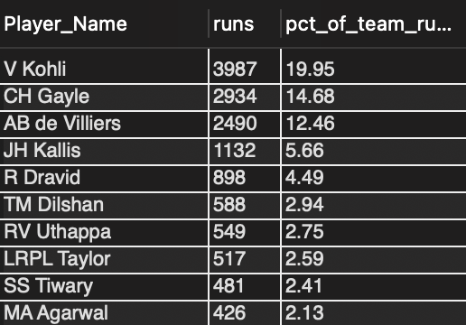

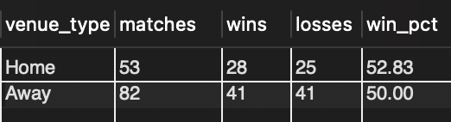

Approach (supported) →
Use the season win-trend query and top run-contributor query to build visuals from executed results.
Do not assert ranges, contribution shares, home percentages or trophy-drought causes without direct query output and supporting evidence.
Previously claimed figures and strategy prescriptions have been removed.

Q10 How would you approach this problem, if the objective and subjective questions weren't given?
1. Define the Core Objectives
- Clearly establish what defines a “top-performing” and “reliable” player using measurable KPIs.
- Focus on IPL-specific performance metrics rather than generic T20 stats.
- Incorporate cost-effectiveness as a key factor to ensure practical auction decisions.

2. Collect and Prepare Data
- Gather historical IPL data, including match-level performance, player statistics, and auction details.
- Perform data cleaning and preprocessing to handle missing values, duplicates, and inconsistencies.
- Structure the data to make it suitable for analysis and comparison across seasons.

3. Player Performance Analysis
Batting Analysis
- Evaluate players based on runs, strike rate, and average to measure both scoring ability and consistency.
- Analyse performance in high-pressure situations such as death overs and run chases.
- Identify players with high impact contributions, even in short innings.
Bowling Analysis
- Assess economy rate, wickets, and bowling strike rate to measure effectiveness.
- Study performance in powerplay and death overs, which are critical phases of the game.
- Identify bowlers who consistently deliver match-winning spells.
Fielding and Wicketkeeping
- Consider contributions like catches, stumpings, and run-outs.
- Evaluate players who add value through fielding efficiency and agility.
Overall Player Value
- Measure contribution in terms of match outcomes and team success.
- Factor in fitness, availability, and consistency across seasons.

4. Auction Strategy Development
- Compare player performance with auction price to identify value-for-money players.
- Build a role-based squad, ensuring coverage for all positions such as openers, finishers, all-rounders, and specialist bowlers.
- Maintain a balance between experienced players and young talent for stability and future growth.
- Optimize the combination of Indian and overseas players within league constraints.
- Focus on budget allocation, targeting undervalued players with high potential.

5. Predictive and Statistical Analysis
- Use regression techniques to forecast future performance based on past data.
- Apply clustering methods to group players with similar playing styles and effectiveness.
- Perform scenario analysis to simulate different auction strategies under budget constraints.

Conclusion and Recommendations
- Identify players who offer the best combination of performance and cost efficiency.
- Highlight gaps in previous team selections and areas needing improvement.
- Provide data-driven recommendations to build a more balanced and competitive squad for future auctions.

Q11 In the "Match" table, some entries in the "Opponent_Team" column are incorrectly spelled as "Delhi_Capitals" instead of "Delhi_Daredevils". Write an SQL query to replace all occurrences of "Delhi_Capitals" with "Delhi_Daredevils".
QUERY →
-- Distinct Team_1 names
SELECT DISTINCT Team_Name AS Team1_Names
FROM Team t
JOIN Matches m ON m.Team_1 = t.Team_Id
ORDER BY Team_Name;
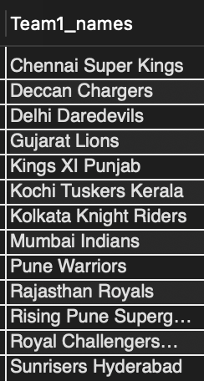

-- Distinct Team_2 names
SELECT DISTINCT Team_Name AS Team2_Names
FROM Team t
JOIN Matches m ON m.Team_2 = t.Team_Id
ORDER BY Team_Name;

Schema verification →
Matches contains Team_1 and Team_2 foreign keys; no Opponent_Team column exists. Therefore no UPDATE is required.
Verification approach →
Use the two retained SELECT statements to inspect names reached through Team_1 and Team_2.
- Both joins resolve names from Team.Team_Name rather than a text field in Matches.
- No Opponent_Team field is available to update.
- Conclusion →
- No UPDATE is required.

